A Report on
“DRUG INTERACTION AND ADVERSE-EFFECT PREDICTOR”
for
Mini Project of AIMLH/DSHSC Lab, (BE Sem-VII)
in
Department of Artificial Intelligence and Data Science
By
123A8028 | Aditya Koparkar
123A8041 | Omer Ovias
123A1049 | Khalid Jalal
224A7064 | Adil Arkate
Under the guidance of
Prof. Gayatri Satpute


UNIVERSITY OF MUMBAI
AY 2026-2027
SIES Graduate School of Technology
Sri Chandrasekarendra Saraswati Vidyapuram Sector-V, Nerul, Navi Mumbai,
Maharashtra 400706
Academic Year 2026-27

CERTIFICATE
This is to certify that the project entitled “Drug Interaction and Adverse-Effect Predictor” is a bona fide work carried out by:
Aditya Koparkar, Omer Ovias, Khalid Jalal and Adil Arkate
submitted to the University of Mumbai in partial fulfillment of the requirements for the Mini Project of the AIMLH/DSHSC Lab of Final Year, (BE Sem-VII) in the Department of Artificial Intelligence and Data Science, as laid down by the University of Mumbai during academic year 2026-27.
Internal Guide
We have examined this report as per University requirements at SIES Graduate School of Technology, Nerul (E), Navi Mumbai on ____________________.
Name of External Examiner: __________________________________________
Signature with Date: ________________________________________________
Name of Internal Examiner: __________________________________________
Signature with Date: ________________________________________________

ACKNOWLEDGEMENT
I would like to express my sincere gratitude to my Internal Guide, Prof. Gayatri Satpute, for her valuable guidance, suggestions, and continuous support throughout the completion of this mini project.
I also thank the Head of the Department and our Principal, Dr. K. Lakshmisudha, for their support and for providing the facilities required to carry out this work.
Finally, I thank everyone who supported me directly or indirectly in the successful completion of this mini project.
Mini Project Team

ABSTRACT
Drug-drug interactions (DDIs) can alter therapeutic effects and increase the risk of adverse outcomes, especially when people take multiple medicines. This project presents a web-based research prototype that combines a biomedical knowledge graph with graph neural networks to screen a medication list for known and predicted interactions, estimate possible side effects, rank risks, and provide supporting explanations. The data pipeline integrates open redistributions of the TDC DrugBank DDI benchmark, PrimeKG, TWOSIDES, and DDInter. The resulting knowledge graph represents drugs alongside proteins, enzymes, transporters, side effects, diseases, and drug classes. The project evaluates fingerprint-based logistic-regression and XGBoost baselines against relational graph convolutional and graph attention models. The served model is an R-GCN with three output heads: interaction probability, interaction type, and polypharmacy side effects. The interface is built with React and Vite and communicates with a FastAPI backend. It includes medication search, optional patient context, pair-level explanations, graph exploration, analytics, prescription-text medication extraction, evidence lookup, and audit-related functionality. On the merged-label test evaluation, the R-GCN achieved AUROC 0.992 and AUPRC 0.991 on a random split; on the more demanding cold-start split, these values were 0.870 and 0.863. Performance decreases under degree-matched unlabelled-pair evaluation, and the cold-start mean AUPRC for side-effect prediction is 0.174. These results support the prototype’s research value but do not establish clinical validity. Unknown pairs are treated as unlabelled rather than safe, and the system is intended only as decision support, never as a substitute for a pharmacist or prescriber.
Keywords: drug-drug interactions, biomedical knowledge graph, R-GCN, adverse effects, explainable AI, decision support

CONTENTS
Section | Name of Topic | Page Number
1 | Introduction | 1
1.1 | Background and project overview | 1
1.2 | Problem statement | 1
1.3 | Objectives and scope | 1
2 | Methodology | 2
2.1 | Data sources and knowledge graph | 2
2.2 | Data preparation and splits | 2
2.3 | Models and outputs | 2
3 | Implementation | 3
3.1 | System architecture | 3
3.2 | Application modules and workflow | 3
3.3 | Explainability and safety rules | 3
4 | Experiment and Results | 4
4.1 | Evaluation setup | 4
4.2 | Interaction prediction results | 4
4.3 | Side-effect and explanation results | 5
4.4 | Limitations | 5
5 | Conclusion and Future Work | 6
6 | References | 7

1 INTRODUCTION

1.1 Background and Project Overview
Patients may use several medicines at the same time. When two medicines interact, one may change the effect, concentration, or adverse-effect profile of the other. A medication review therefore needs to consider not only isolated drug properties, but also pairwise relationships, clinical evidence, and the patient context. Manual checking across reference sources can be time-consuming, and a simple list of drug pairs does not explain why an interaction is suspected.
The Drug Interaction and Adverse-Effect Predictor is a research prototype that checks each pair in a user-supplied medication list. It combines known interaction records with a learned graph model, estimates possible side effects, applies a severity ranking, and presents evidence and explanation paths. The project is designed to make model output inspectable: a user can open a drug pair, view a path through relevant biomedical entities, and explore the surrounding knowledge graph.

1.2 Problem Statement
The problem addressed is how to support screening of medication combinations by combining heterogeneous biomedical data and machine learning, while retaining a traceable explanation for each flagged pair. The system must also handle incomplete records: an interaction absent from a public database is not necessarily absent in reality. Accordingly, the application reports “no known or predicted interaction” rather than declaring a pair safe.

1.3 Objectives
- Build a unified biomedical knowledge graph from multiple open drug and adverse-effect sources.
- Compare molecular-fingerprint baselines with relational graph neural networks for interaction prediction.
- Estimate interaction type and likely pair-level side effects in addition to interaction probability.
- Rank flagged combinations by severity and provide evidence-aware, graph-path explanations.
- Deliver a web interface for medication-list screening, patient context, analytics, and graph exploration.
- Evaluate random and cold-start splits and clearly communicate uncertainty and limitations.

1.4 Scope
The prototype focuses on 1,706 small-molecule drugs represented in the assembled data. It is a research and educational decision-support system, not a medical device. Its reported offline metrics do not establish prospective clinical performance, and every result requires confirmation against an authoritative source and a qualified healthcare professional.

2 METHODOLOGY

2.1 Data Sources and Knowledge Graph Construction
The pipeline harmonizes drug identities and builds a heterogeneous biomedical graph. Interaction pairs remain supervised labels rather than ordinary explanatory edges, reducing direct label leakage into message passing.
Source | Contribution in this project | Join / handling
TDC DrugBank DDI | Drug universe of 1,706 drugs, SMILES and 86 typed interaction labels | DrugBank identifiers
PrimeKG | Drug names, targets, enzymes, transporters, carriers, side effects, indications, contraindications, classes and extra DDI links | DrugBank identifiers
TWOSIDES | Pair-level polypharmacy side effects; 915 retained effects across 50,150 mapped pairs | PubChem CID → InChIKey connectivity block → DrugBank
DDInter | Curated Major / Moderate / Minor severity and additional known interactions | Drug name to DrugBank name

The graph contains 7,456 nodes (drugs, proteins, diseases, effects and ATC classes) and approximately 117,000 biomedical relation edges. After deduplication, 526,105 of 1,454,365 possible pairs are known interactions; individual source counts overlap.

2.2 Data Preparation and Evaluation Splits
Drug structures use Morgan fingerprints (radius 2, 1,024 bits) for baseline features and initial R-GCN drug-node features. Biomedical links connect drugs to enzymes, targets, transporters, carriers, side effects and indications.
Two evaluation regimes are used. The random split divides known interactions 80/10/10 into training, validation and test sets. In the cold-start split, drugs are partitioned so test pairs contain at least one drug absent from training. This is more realistic for new drugs, although their graph neighbourhoods and fingerprints may still be available.
Unrecorded pairs are unlabelled, not confirmed negatives. Evaluation uses uniform unlabelled pairs and a harder degree-matched set whose endpoints are sampled in proportion to interaction degree. AUROC, AUPRC, F1 and Hits@K are reported; the F1 threshold is tuned on validation data. Unlabelled pairs may contain real undocumented interactions, so these are not clinical error rates.

2.3 Model Design
- Fingerprint baselines: logistic regression (SGD) and XGBoost classify the concatenated fingerprints of the two drugs; the score is averaged over both drug orders.
- R-GCN: relational graph convolution passes messages across typed biomedical relations and a dedicated interaction channel. This is the model served by the web application.
- R-GAT: relational graph attention learns relation-neighbour weighting and is evaluated as an alternative graph model.
- R-GCN + GIN: an experimental variant initializes drug representations with a graph-isomorphism-style molecular encoder over atoms and bonds. It is not served because it performs worse than fingerprint-based R-GCN on cold-start evaluation.
The graph model uses three prediction heads: (1) interaction probability, (2) interaction type across 86 DrugBank types, and (3) multi-label side-effect probabilities over 915 TWOSIDES effects. Severity uses DDInter’s curated label where available; otherwise, the system labels its rule-derived output as a type-based estimate.

3 IMPLEMENTATION

3.1 System Architecture
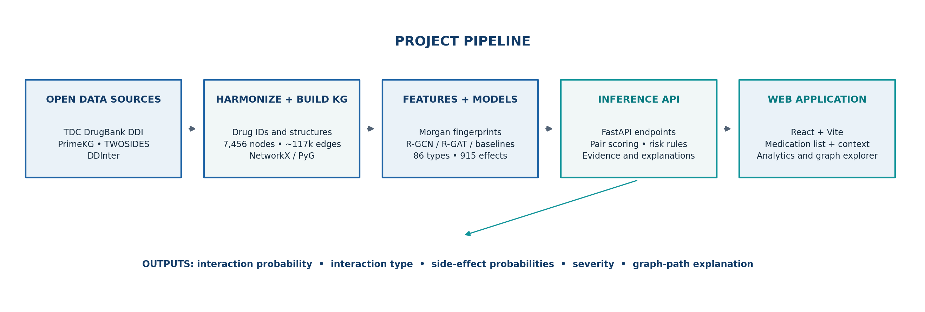
Figure 1. Data-to-interface pipeline described by the submitted project source and user guide.
The project is separated into a Python modelling package, a FastAPI backend, and a React/Vite web frontend. Preprocessed parquet, NumPy and PyTorch Geometric objects support graph construction and inference; trained model weights and evaluation reports are stored under artifacts/ and reports/. The backend exposes JSON endpoints for medication search, list analysis, pair details, graph neighbourhoods, metrics, model-card metadata, prescription extraction, FAERS evidence, alternatives and audit operations.

3.2 Application Modules and Workflow
Module | Purpose
Medication search | Searches recognized drug names and supports selected brand-to-generic normalization; RxNorm lookup can resolve names not found locally.
Medication-list analysis | Accepts 2–20 recognized drugs, scores all pair combinations, ranks flagged pairs, and returns overall regimen risk.
Patient context | Optional age, kidney/liver function, conditions and allergies can trigger rule-based warnings and contraindication matching.
Pair detail and evidence | Shows known/predicted evidence, probable interaction type, top side effects, risk/severity source and drug cards.
Knowledge-graph explorer | Visualizes a drug neighbourhood and highlights paths between two drugs through biomedical entities.
Analytics and model card | Displays performance metrics, split and label filters, exploratory data summaries and intended-use limitations.
Additional support | Prescription text NER, FAERS report-count evidence, safer-alternative suggestions and role-related audit logging are present in the source package.

3.3 Risk Ranking and Explainability
The result screen ranks pairs by severity, evidence and risk score. The combined regimen score aggregates flagged pairs with severity weights defined in the source configuration: Major = 1.0, Moderate = 0.6, Minor = 0.3 and None = 0.0. Context alerts are applied separately and may highlight an issue even when a pairwise score is not the highest concern.
The path explainer enumerates real knowledge-graph paths involving shared enzymes, targets, transporters, carriers, side effects, ATC classes, indications or short protein-protein bridges. The path ranking uses relation weights and a specificity factor that favours entities connected to fewer drugs. GNNExplainer adds a separate model-attribution view by learning a soft mask over graph links that contribute to the two drug embeddings. These are complementary views: a graph path is a traceable association, not proof of causation or the full internal reasoning of the model.

4 EXPERIMENT AND RESULTS

4.1 Evaluation Setup
The results below are taken from the submitted project’s MODEL_CARD.md and reports/metrics.json. The headline table uses merged labels and uniformly sampled unlabelled test pairs. A separate degree-matched set is used as a harder evaluation. Random-split scores are included for comparison, but cold-start performance is the more realistic indicator for drugs not encountered during training.

4.2 Interaction Prediction Results
Model | Split | AUROC | AUPRC | F1
Fingerprint LR | Random | 0.700 | 0.681 | 0.693
Fingerprint LR | Cold-start | 0.613 | 0.597 | 0.670
Fingerprint XGBoost | Random | 0.884 | 0.882 | 0.808
Fingerprint XGBoost | Cold-start | 0.780 | 0.774 | 0.729
R-GCN (served) | Random | 0.992 | 0.991 | 0.960
R-GCN (served) | Cold-start | 0.870 | 0.863 | 0.802
R-GAT | Random | 0.992 | 0.991 | 0.958
R-GAT | Cold-start | 0.842 | 0.844 | 0.772
R-GCN + GIN | Random | 0.992 | 0.992 | 0.959
R-GCN + GIN | Cold-start | 0.827 | 0.830 | 0.758

Table 1. Merged-label test results on uniform unlabelled pairs. Values reproduced from the project model card.
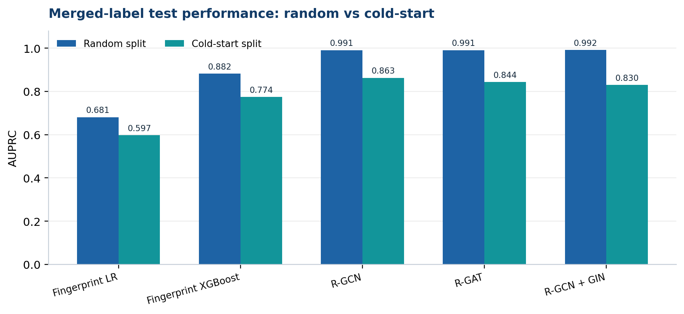
Figure 2. AUPRC comparison highlights the random-to-cold-start performance gap.
R-GCN and R-GAT perform best on the random split, with AUROC close to 0.992 and AUPRC close to 0.991. However, the R-GCN score drops to AUROC 0.870 and AUPRC 0.863 on cold-start evaluation. Fingerprint XGBoost also drops from AUROC 0.884 to 0.780. This difference is material: high random-split performance alone should not be interpreted as equivalent performance on new drugs.

4.3 Harder Evaluation and Auxiliary Outputs
Evaluation slice | R-GCN result | Interpretation
Cold-start; degree-matched unlabelled pairs | AUROC 0.843; AUPRC 0.837; F1 0.780 | Harder ranking task; some unlabelled pairs may be undocumented interactions.
Interaction-type head; cold-start | Accuracy 0.774; macro-F1 0.730 | Predicts one of 86 interaction-type labels.
Side-effect head; cold-start | Mean AUPRC 0.174; mean AUROC 0.722 | Multi-label side-effect prediction is substantially more difficult and imbalanced.
Graph explanation evaluation; 200 random known test pairs | Top-5 overlap 0.11; model top neighbour on a KG path 0.37 | Model attribution and shared-path explanation often provide different but complementary views.

4.4 Example Case Study and Explanation Agreement
The source case-study report includes the pair Warfarin + Ibuprofen with a model score of 0.76. Its top model-attribution neighbour is CYP2C9, while the highest ranked knowledge-graph path node is gastrointestinal hemorrhage. This illustrates how the application can combine a numerical risk estimate with an interpretable biomedical path. It is only a software case study: a model score is not an individualized probability of harm and should not be used to start, stop or change a medication.
For 10 curated case studies, the model’s top neighbour lay on a knowledge-graph path in 80% of pairs. On 200 random known test pairs, a path was found for 155 pairs; the model’s top neighbour lay on a path in 37% of pairs and top-5 overlap between the two rankings was 11%. Keeping only the model’s top-eight attributed links retained a mean score of 0.79 compared with 0.80 using all links. The report interprets these values as evidence that the attribution can be sufficient to preserve the score, while many redundant links may carry similar signal.

4.5 Limitations
- The project is not clinically validated and has no prospective evaluation.
- Unknown pairs are unlabelled rather than confirmed negative; “no interaction found” does not mean safe.
- Random-split results are optimistic compared with cold-start; no time-based split is reported.
- Spontaneous-report sources such as TWOSIDES/FAERS are affected by reporting bias and do not establish causation.
- Coverage is limited to 1,706 small-molecule drugs; biologics/newer medicines may be absent, and SIDER was last updated in 2016.
- Severity for pairs without DDInter annotation is a project rule-based estimate; some mechanism details are unavailable in the open data.

5 CONCLUSION AND FUTURE WORK
This mini project demonstrates an end-to-end approach for medication-combination screening that joins heterogeneous biomedical data, graph neural network predictions and an interactive interface. It integrates known interaction evidence with prediction, side-effect ranking, severity handling and explanations grounded in a biomedical knowledge graph. The R-GCN model provides stronger offline interaction-ranking results than the fingerprint baselines, especially on the random split; the cold-start and degree-matched results show why model assessment must go beyond an easy random partition.
The application also emphasizes responsible interpretation. It does not label an unflagged combination as safe, distinguishes curated severity from type-based estimates, and provides a disclaimer that predictions may be wrong or incomplete. The system should be considered an educational/research prototype until clinically validated.

Future Work
- Conduct temporal and external validation using carefully versioned datasets and realistic clinical review protocols.
- Improve side-effect prediction through better handling of label imbalance, calibration and per-label validation.
- Expand coverage to newer medicines and additional trustworthy evidence sources while documenting licensing and provenance.
- Evaluate explanations with pharmacists/clinicians and refine the presentation of uncertainty, evidence strength and data freshness.
- Add safeguards and usability testing before any clinical workflow integration; retain mandatory human verification.

6 REFERENCES
[1] Drug Interaction and Adverse-Effect Predictor, submitted project source package: README.md, USER_GUIDE.md, MODEL_CARD.md, reports/metrics.json, reports/eda.md, reports/case_studies.md, and reports/explanation_agreement.md.
[2] Therapeutics Data Commons (TDC), DrugBank Drug-Drug Interaction benchmark / DeepDDI subset, as used by the submitted project data pipeline.
[3] PrimeKG biomedical knowledge graph, Harvard Dataverse redistribution, as described by the submitted project README and data builder.
[4] Tatonetti, N. P., Ye, P. P., Daneshjou, R., and Altman, R. B. “Data-driven prediction of drug effects and interactions.” Science Translational Medicine, 4(125), 125ra31, 2012.
[5] DDInter database, used in the project for curated Major, Moderate and Minor drug-interaction severity annotations.
[6] Schlichtkrull, M. et al. “Modeling Relational Data with Graph Convolutional Networks.” The Semantic Web, ESWC 2018, pp. 593–607.
[7] Veličković, P. et al. “Graph Attention Networks.” International Conference on Learning Representations (ICLR), 2018.
[8] Ying, R. et al. “GNNExplainer: Generating Explanations for Graph Neural Networks.” Advances in Neural Information Processing Systems, 32, 2019.
[9] PyTorch Geometric documentation, relational graph learning components and graph neural network implementation library, https://pytorch-geometric.readthedocs.io/.

